* **Lab Task 1**

Display the flight ID, country name, ticket price, and increased ticket price by 15.5% as New Ticket Price.

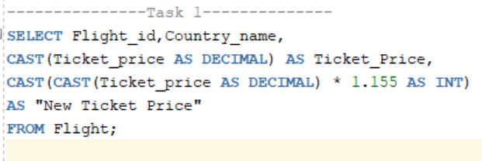

Output:

